**Media Streaming with IBM Cloud Video Streaming**

**Phase 2: Innovation**

**Team:**

Prisha C (211521104118)

Devadarshini S (211521104035)

Heshiya Gayathri S (211521104053)

Deepthi J Mercy (211521104034)

Esha G (211521104042)

**Introduction:**

Cloud computing technology proposes a new mobile video streaming framework that combines adaptive mobile streaming and efficient social video sharing. This framework uses a private agent to provide efficient video streaming services for each user, adjusting the streaming based on link quality feedback. It also monitors social network interactions and uses scalable video coding and adaptive streaming techniques to achieve the best possible quality of video streaming services. The prototype demonstrates the potential of this framework on large-scale implementation.

Cloud computing is transforming the IT industry, with enterprises developing their own infrastructures. Mobile multimedia faces challenges in efficient video streaming due to mobile devices. Cloud servers perform video rendering and encoding, streamed over wireless networks to mobile devices. Higher bit rates are required for better video quality and response time.

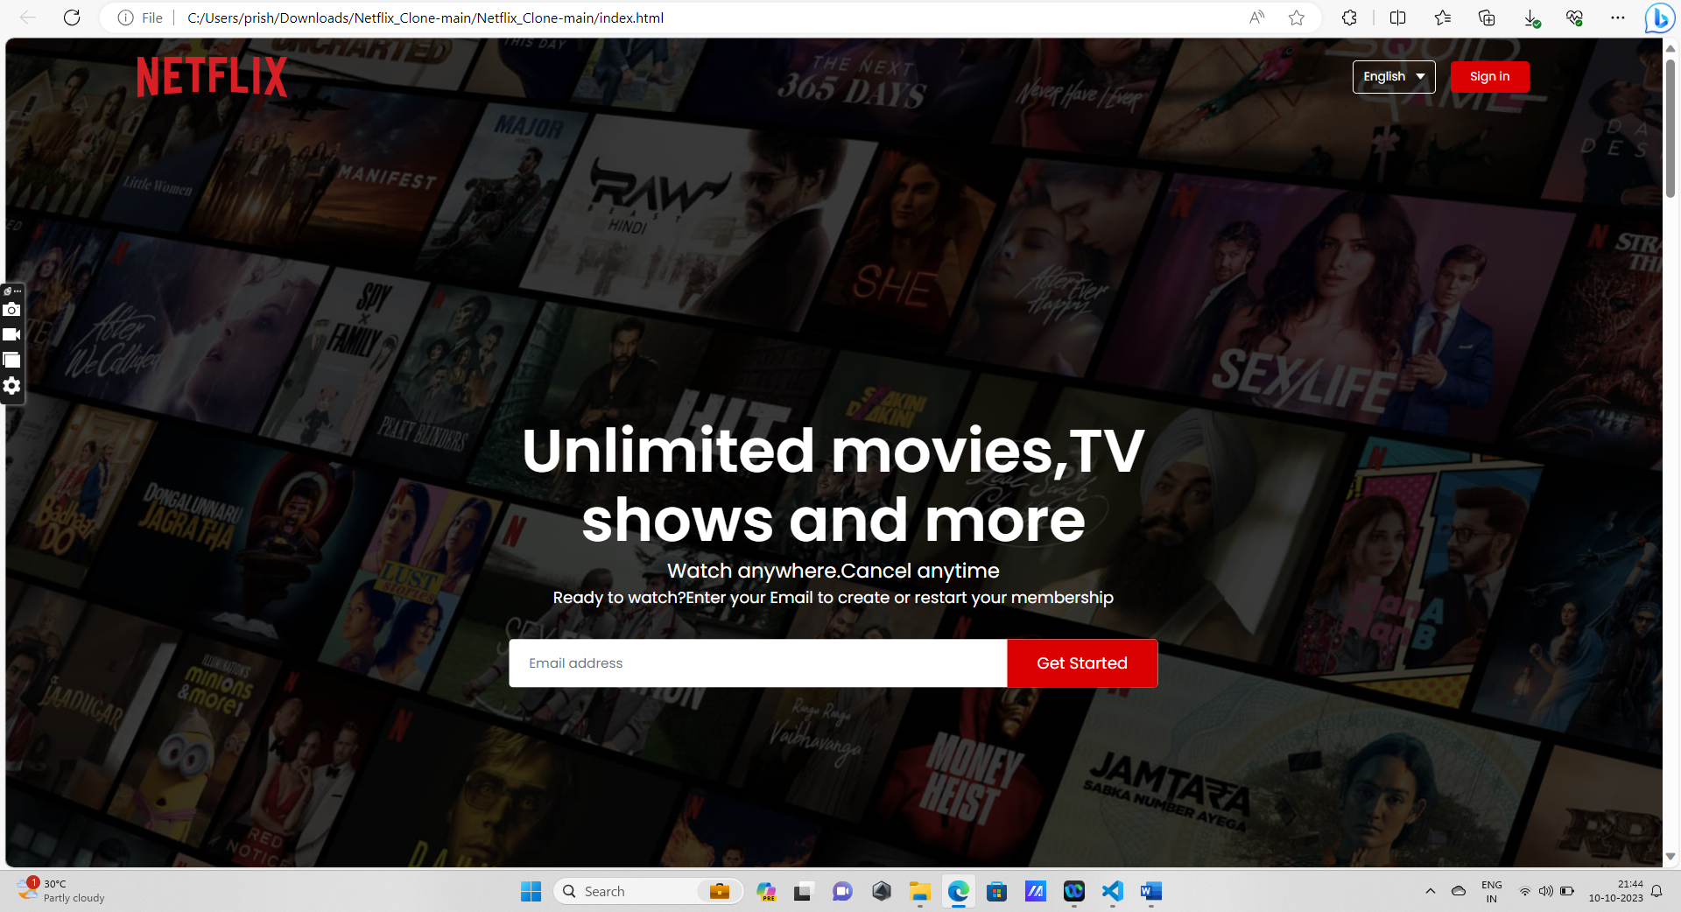

**FIG 1.** A basic front end for a Netflix clone streaming platform

**FEATURES OF A STREAMING PLATFORM:**

1. **User Registration and profile:**

User registration in a streaming platform is a critical process that allows users to create accounts, access content, personalize their experience, and manage their preferences.

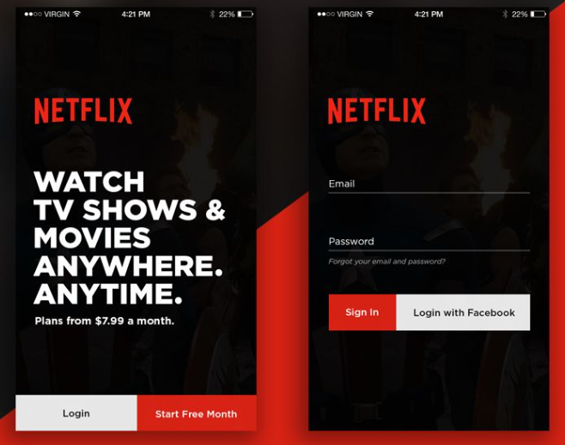

**FIG 2.**User registration process in Netflix

1. **Content Library:**

The content library in a streaming platform is the collection of movies, TV shows, documentaries, original series, live events, and other video content that users can access and stream on-demand. The success and appeal of a streaming platform often heavily depend on the richness, diversity, and relevance of its content library.

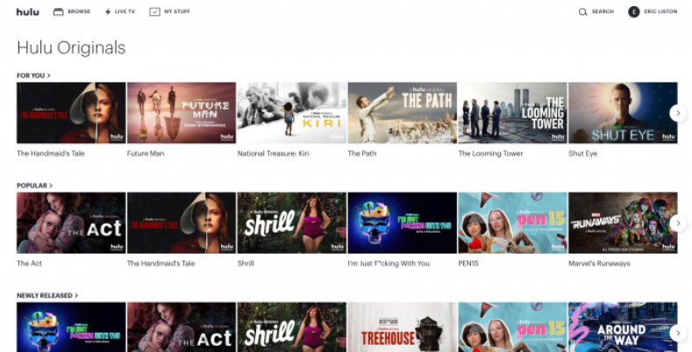

**FIG 3.**Content library in Hulu

1. **Search and Recommendations:**

Search and recommendations are fundamental features in a streaming platform that enhance user engagement and help users discover relevant content.

Search functionality includes search bar, auto suggestions, search filters, advanced search, voice search, spelling corrections, search history and popular searches.

Recommendations include trending content, similar content, recently released, genre-based recommendations, user ratings and reviews, daily picks and continue watching.

1. **Streaming Quality:**

Streaming quality is the measure of how well a video is delivered to the viewer over the internet. Streaming quality depends on many factors, such as the resolution, frame rate, bitrate, encoding, internet speed, and network conditions of the video stream. Higher streaming quality usually means higher video clarity, smoother motion, and better sound, but it also requires more bandwidth and processing power. Therefore, it is important to optimize your streaming quality for your specific needs and circumstances.

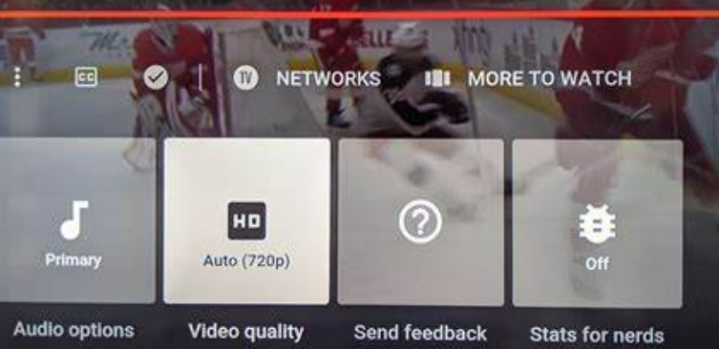

**FIG 4.** Streaming quality bar in YouTube

1. **Offline Viewing:**

Option to download content for offline viewing, allowing users to watch without an internet connection. Offline viewing option in streaming is a feature that allows you to download movies and TV shows from your favorite streaming services and watch them without an internet connection. This can be useful when you are traveling, have limited data, or want to save battery life.

1. **Multiple Device Support:**

Multiple device support in streaming platform is a feature that allows users to watch video content on different devices such as smartphones, tablets, laptops, smart TVs, etc. with the same account. This feature can enhance the user experience and satisfaction, as well as increase the retention and loyalty of the users.

**FIG 5.** Streaming over a range of devices

1. **Parental Controls:**

Parental controls in streaming platform are features that allow you to limit or restrict the access of your children to inappropriate or mature content on the platform. Parental controls can help you protect your children from seeing or hearing things that are not suitable for their age or development.

1. **Live TV and Events:**

Live TV and events in streaming platform are features that allow you to watch live broadcasts of television channels or special events on your device. Live TV and events can provide you with real-time entertainment, news, sports, and more. However, not all streaming platforms offer live TV and events, and there may be some limitations and restrictions on what channels or events you can access, or how much they cost.

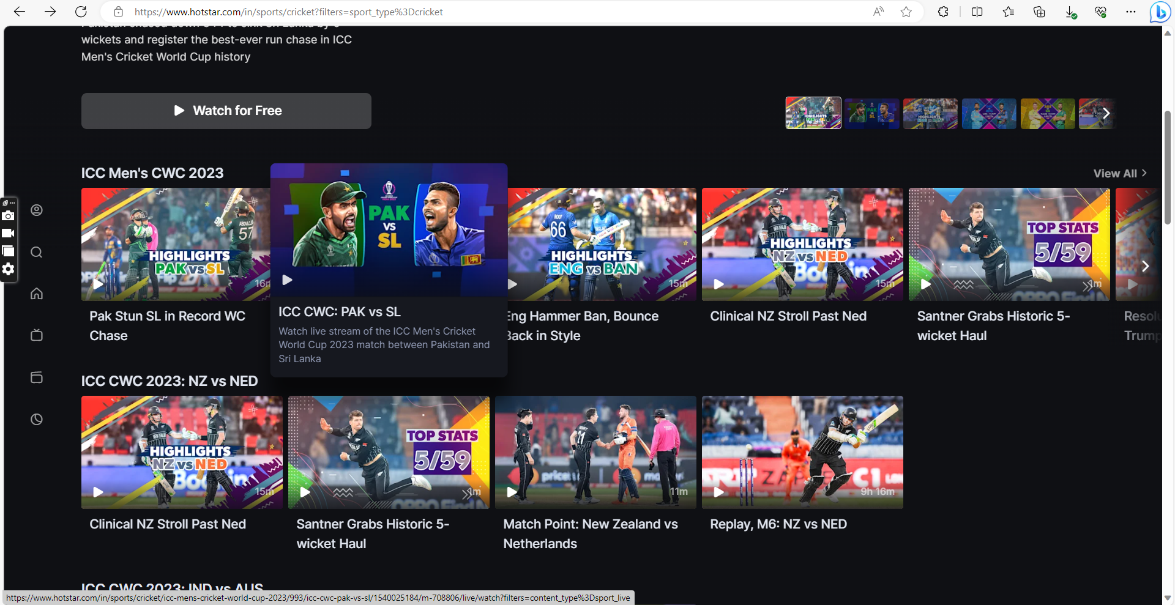

**FIG 6.** Live streaming

1. **Custom Playlists:**

Custom playlists in streaming platform are features that allow you to create your own collections of songs based on your preferences, moods, genres, artists, or any other criteria. Custom playlists can help you organize your music library, discover new tracks, and share your taste with others. 

1. **Notifications:**

Notifications in streaming platform are features that allow you to receive updates and alerts about the content and activities on the platform. Notifications can help you stay informed, engaged, and connected with your favorite streamers, channels, and communities. 

1. **Community Interaction:**

Community interaction in streaming platform is a feature that allows you to communicate and engage with other users who share your interest in the same video content. Community interaction can enhance your social experience, enjoyment, and loyalty on the platform.

Integration of social features, enabling users to comment, discuss, and share recommendations with others.

1. **In-App Purchases or Subscriptions:**

In-app purchases or subscriptions in streaming services are features that allow users to buy additional or premium content within the app. In-app purchases are usually one-time payments that unlock specific items or functions, such as ad removal, extra levels, or special skins. Subscriptions are recurring payments that grant users access to a range of content or services, such as unlimited streaming, offline viewing or shows.

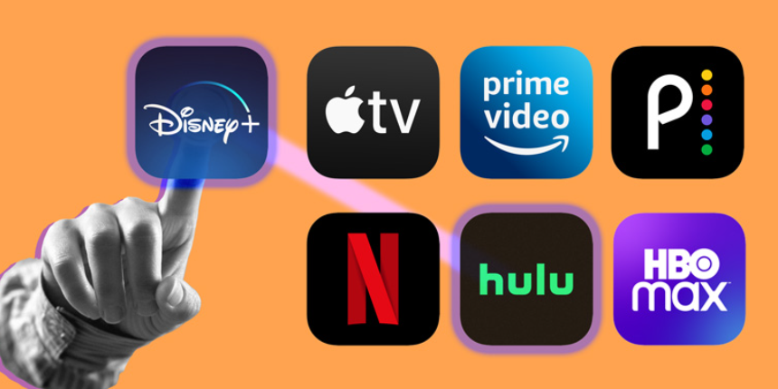

**FIG 7.** Some paid platforms already available

1. **Cross-Platform Syncing:**

Cross-platform syncing in streaming services is a feature that allows you to access your content and preferences across different devices and platforms. Cross-platform syncing can help you enjoy a seamless and consistent streaming experience, as well as save your time and data. Different streaming services have different ways of enabling and managing cross-platform syncing, and some may offer more options and flexibility than others.